1. Eclipse IDE – Download Eclipse Eclipse IDE for Enterprise Java and Web Developers select pannunga.
Eclipse Packages
2. Apache Tomcat 10.1 – Download Tomcat 10.1 Windows use pannina 64-bit ZIP download pannunga.
Apache Tomcat 10 Software Downloads
3. Java JDK 17 – Download Java JDK Windows 64-bit installer select pannunga.
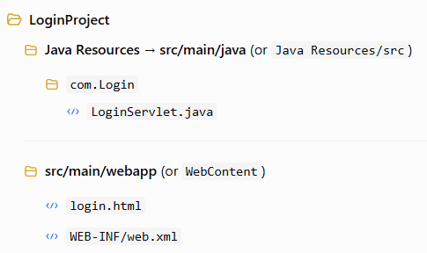

Java SE 17.0.13 and later
Correct settings:
- Java: 17
- Tomcat: 10.1
- Dynamic Web Module: 6.0
- Package: com.Login
- Class: LoginServlet
Indha versions unga jakarta.servlet code-ku suitable. Tomcat 10.1-ku Java 11 or later thevai.

Apache Tomcat 10 Software Downloads

Step 1: login.html create pannunga
- src/main/webapp (or WebContent) mela right-click pannunga.
- New → HTML File click pannunga.
- File Name:
Step 2: web.xml create/check pannunga
WEB-INF folder-kulla web.xml irukkanum.

LoginServlet.Java

package com.Login;
import java.io.IOException;
import java.io.PrintWriter;

import jakarta.servlet.ServletException;
import jakarta.servlet.annotation.WebServlet;
import jakarta.servlet.http.HttpServlet;
import jakarta.servlet.http.HttpServletRequest;
import jakarta.servlet.http.HttpServletResponse;

@WebServlet("/login")
public class LoginServlet extends HttpServlet
{

private static final long serialVersionUID = 1L;

protected void doPost(HttpServletRequest request,
HttpServletResponse response)
throws ServletException, IOException {

response.setContentType("text/html");

PrintWriter out = response.getWriter();

String username = request.getParameter("username");
String password = request.getParameter("password");

if ("admin".equals(username) && "1234".equals(password)) {
out.println("<h2>Login Successful</h2>");
out.println("<p>Welcome " + username + "</p>");
} else {
out.println("<h2>Login Failed</h2>");
out.println("<p>Invalid Username or Password</p>");
}
}
protected void doGet(HttpServletRequest request, HttpServletResponse response)
throws ServletException, IOException
{

doPost(request, response);

}
}
Web.xml
<?xml version="1.0" encoding="UTF-8"?>
<web-app xmlns:xsi="http://www.w3.org/2001/XMLSchema-instance"
xmlns="https://jakarta.ee/xml/ns/jakartaee"
xsi:schemaLocation="https://jakarta.ee/xml/ns/jakartaee
https://jakarta.ee/xml/ns/jakartaee/web-app_6_0.xsd"
version="6.0">

</web-app>

login.html

<!DOCTYPE html>
<html>
<head>
<meta charset="UTF-8">
<title> Login Page</title>
</head>
<body>
<h2>Login Page</h2>

<form action="login" method="post">

User name:
<input type="text" name="username">

<br><br>

Password:
<input type="password" name="password">

<br><br>

<input type="submit" value="Login">

</form>

</body>
</html>

